硬件架构规范 HW Architecture Specification
 | 文件编号 / Document ID | SGS-FS-HW-xx
 | 密级 / Confidentiality
项目名 / Project Name
项目编号 / Project ID
编制 / Author
审核 / Reviewer
批准 / Approver
日期 / Date
版本 / Version
发布范围 / Distribution list

注意 / Notice:
- 本文档的目的是帮助作者制作满足ISO26262相关要求的工作产品
This document is aimed to assist the author to develop work products in compliance with the corresponding requirements in ISO26262.
- 通过本模板所创建的工作产品不能认为其一定会自动满足ISO26262的要求
The work products generated via this template cannot be treated as are in compliance with requirements of ISO26262 automatically.
- 本文档内容仅供参考
The content of this document is for reference only
- 如有问题，请和我们联系：chad.huang@sgs.com
please contact with us via chad.huang@sgs.com if any question.
- 此模板知识产权归通标标准技术服务（上海）有限公司所有，仅限该咨询项目使用。未经书面许可，禁止打印、复印、转发

模板变更履历 / Template Change History
版本  Version | 状态  Status | 编制人  Author | 编制日期  Date | 批准人  Approver | 批准日期  Approve Date | 内容描述  Description

HWA变更履历 / HWA Change History
版本  Version | 状态  Status | 编制人  Author | 编制日期  Date | 批准人  Approver | 批准日期  Approve Date | 内容描述  Description

目录 / Table of Contents
1 概要说明 / General Information 5
1.1 文档目的 / Document Purpose 5
1.2 输入文档 / Input Document 5
1.3 参考文档 / Reference Document 5
1.4 术语和缩略语 / Terms and Abbreviation 5
2 硬件架构概述 / HW architecture overview 6
2.1 硬件架构框图 / HW architecture block diagram 6
2.2 硬件架构描述 / HW architecture description 6
3 硬件架构元素 / HW architecture elements 6
3.1 电源 / LDO 6
3.1.1 架构元素框图 / Block diagram 6
3.1.2 功能描述及硬件需求 / Function description and HW requirements 7
3.1.3 接口 / Interfaces 7
3.2 CAN 8
3.2.1 架构元素框图 / Block Diagram 8

概要说明 / General Information

文档目的 / Document Purpose
Descript the purpose of the EE architecture design.
This document defined the EE architecture of <project name>, describes the partitioning of the complete HW architecture into smaller functional elements (modules).

输入文档 / Input Document
本节描述“系统需求规范”的输入文档，包括但不限于：硬件组件评估的相关流程，相关的安全需求，相关器件的数据手册, 硬件组件评估计划等

序号  No. | 文档名称  Document Name | 文档版本  Version | 文档日期  Date
1 | 系统（安全）需求 / Technical safety concept
2 | 系统架构
3 | HSI
4

参考文档 / Reference Document
序号  No. | 文档名称  Document Name | 文档版本  Version | 文档日期  Date
1

术语和缩略语 / Terms and Abbreviation
术语/缩略语  Terms and Abbreviation | 描述  Description
PCB | printed circuit board
MCU | Microcontroller Unit
EMC | electromagnetic compatibility
CAN | Controller Area Network
LIN | Local Interconnect Network
HSD | High Side
LSD | Low Side
LDO | Low Drop voltage Output
SMPS | Switch Mode Power Supply

硬件架构概述 / HW architecture overview
以下内容为示例或填写说明，请按照实际产品开发进行设计。
This section provides a description of the overall hardware architecture and its lower level modules. Include the overall architecture block diagram and the brief function introduction to the sub-elements.

硬件架构框图 / HW architecture block diagram
This chapter introduce the overall hardware architecture, a block diagram (or a link to an external diagram) of the highest architecture level.
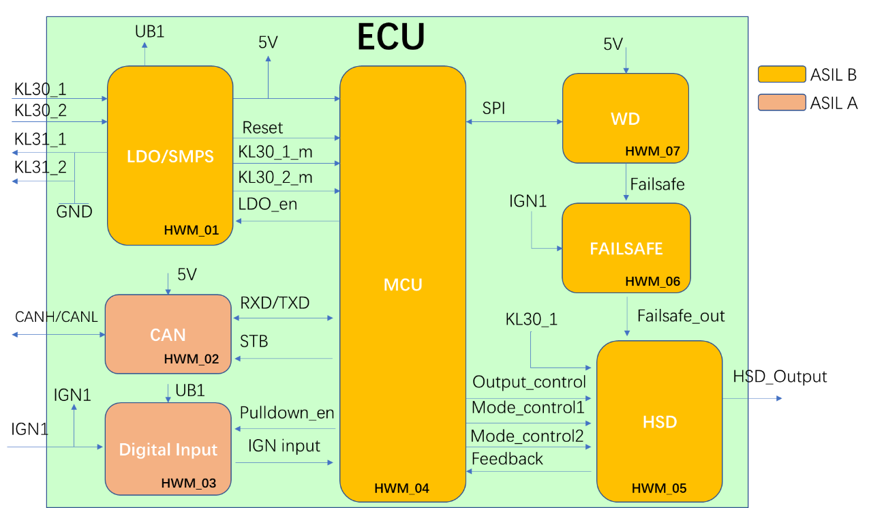

硬件架构描述 / HW architecture description
List the HW architecture elements here, and brief describe it’s function.
ID / Name of HW architecture element | ID of System architecture element | Function description | ASIL
HWM_01 / LDO | SYSM_01 | This is the LDO module, which provide 12V, 5V power to other modules. | ASIL B

硬件架构元素 / HW architecture elements
以下内容为示例，请按照实际产品开发进行设计。

电源 / LDO

架构元素框图 / Block diagram

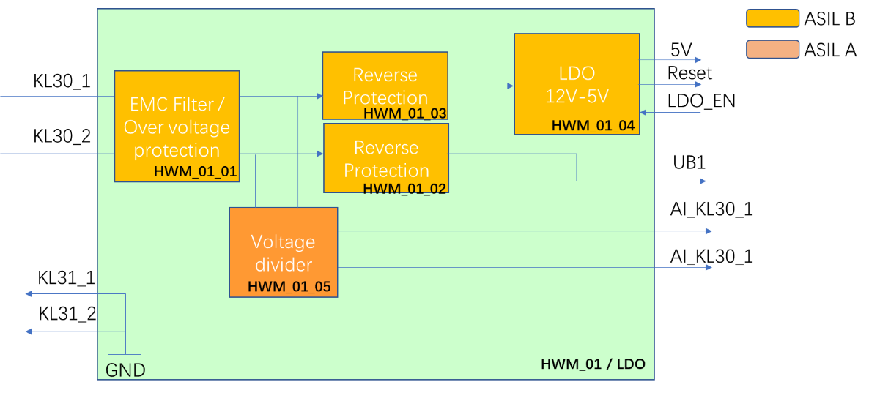

功能描述及硬件需求 / Function description and HW requirements
List the sub-elements here, describe the function of the elements and the corresponding HW (safety) requirements.
Element ID | Function | ASIL | ID of assigned HW Requirements
HWM_01 | This is the LDO module, which provide 12V, 5V power to other modules. | ASIL B | HWR_001  (The general requirements for this whole module.)
HWM_01_01 | 1, EMC filter is used to protect the whole ECU against EMC interfere from KL30_01 and KL30_02.  2, The over voltage protection has the function to protect the whole ECU from voltage higher than 28V by clamp the input voltage to 28V. | ASIL B | HWR_002  (specific hardware requirements)

接口 / Interfaces
List the interfaces of this sub-element here, the external interface (connector) shall consistent with the system architecture, the internal interface shall consistent with the HSI specification.
No. | Interface name | Input / Output | From / To | ASIL | Electrical characteristics
1 | KL30_01 | I | External |  | 9V-16V.
2 | KL30_02 | I | External
3 | 5V | O | HWM_02  HWM_04  HWM_07
4 | UB1 | O | HWM_03

CAN

架构元素框图 / Block Diagram

